While we understand the process of getting cleared through the safety process can seem overwhelming, we remain committed to streamlining the process for all who wish to participate with GLL. There are different criteria for each position as reflected below based upon Little League Regulations, State Law, and Granada Little League Policies. Once the necessary steps are completed and on file with our Safety Officer, you will be issued a GLL Badge which is to be required to be worn while representing Granada Little League during practices or games as a Coach, Manager, or Umpire.

Board Members who are on campus in their official capacity will also be required to wear their badges. Badges from prior years will be updated annually with a new sticker or replaced as needed.

The Manager for each team will serve as the point of contact between the Safety Officer and each Coach. This is done to facilitate efficient communications throughout the Safety Process. The Manager will be responsible for providing the name and email address for each volunteer who will be assisting with practices or games. To start the certification process, please email your manager with your name, email address and Position (Coach, Umpire, etc.)  
  
*For families with multiple players, the volunteer will be cleared through the team of the oldest player registered with GLL. Volunteers only need to be cleared once with GLL and do not need to be cleared with each team they participate with.

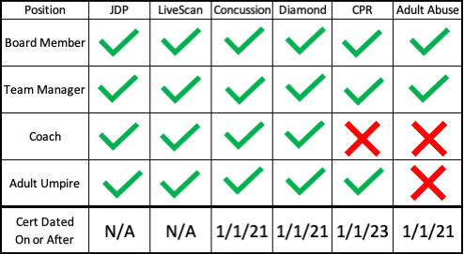

Below are the links and/or instructions for each of the above courses. Once completed, send requested certificates of completion to [Safety@granadalittleleague.com](mailto:Safety@granadalittleleague.org). Certs will be kept on file by GLL for future use until expiration.

**JDP (Little League International) Background Check**

A link will be sent out via email to all volunteers based upon the contact information provided by the Team Managers. The UIC (Umpire in Charge) will send the names and email addresses for all Adult Umpires needing to be cleared. The Safety Officer is notified once the JDP Process has been completed and there is NO NEED to send in any certificate by the applicant.  
  
**LiveScan**

California AB 506 requires all adults volunteering with Youth Sports to be fingerprint background checked if they anticipate having more than 16 hours of contact with youth players in a month or 32 hours in a year. GLL has embraced this process fully and requires ALL Board Members, on-field Managers, Coaches and Adult Umpires to get a Live Scan. The Live Scan remains in place for subsequent years (except in the case of name change) and only needs to be done once.

**Heads Up Concussion Training**

<https://www.train.org/cdctrain/course/1089818/>

Concussion Training is required of all volunteers and is valid for 4 years once completed. The above link will take you to the training course. Send a pdf version of the certificate to [safety@granadalittleleague.com](mailto:safety@granadalittleleague.com)

**Diamond Leader Training**

<https://www.littleleague.org/diamondleader/>

Diamond Leader Training is required of all volunteers and is valid for 4 years once completed. The above link will take you to the training course. Send a pdf version of the certificate to [safety@granadalittleleague.com](mailto:safety@granadalittleleague.com).

**CPR**

<https://ncprf.com/as6wxb>

CPR Training is required of all Managers, Board Members and Adult Umpires. The course is completed online and a completion certificate is sent to the Safety Officer once completed. The Training is valid for 2 years. Please do not take this course unless you are required to per the chart above as the League incurs a cost each time someone completes the course.

**Adult Abuse**

<https://usabmobilecoach.com/courses>

Please use this link and select “Abuse Awareness for Adults” and complete the training. You can use the link above to complete the course or login to your account and select “My Account” from your profile at the top right corner, select My Certifications, Select Print Certificate if you have already taken the course. Once completed, send the certificate (preferably as a PDF) to [Safety@granadalittleleague.com](mailto:Safety@granadalittleleague.com)

Please note that the completion certificate for Adult Abuse can take several hours to generate once you complete the course.